

Mohammed Razia Alangir Banu
N. Siri Chandana Reddy
2520030142
CSE
CO-3 (BFS, DFS)
Waste Sense – Smart Waste Collection & Recycling Optimization System Using BFS, DFS, Kruskal's and Prim's Algorithms

The Waste Sense system uses graph algorithms to optimize waste collection routes and ensure efficient connectivity between smart bins, collection centres, and recycling plants.
- Developed a graph-based waste collection network where vertices represent smart bins, collection centers, and recycling facilities.
- Implemented Breadth First Search (BFS) to identify the shortest reachable waste collection paths from a collection center.
- Implemented Depth First Search (DFS) to explore all connected waste collection locations and detect isolated regions.

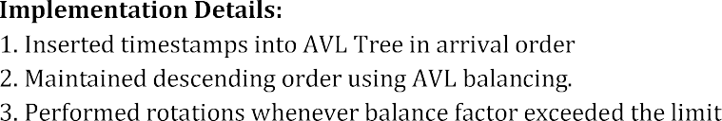
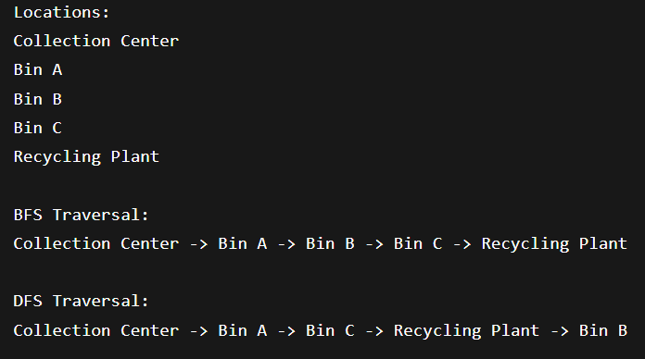

- Create a weighted graph representing the waste collection network.
- Add smart bins, recycling centers, and collection stations as vertices.
- Add roads and transportation costs as weighted edges.
- Use BFS to analyze reachability and nearest collection paths.
- Use DFS to identify connected components in the network.
- Apply Kruskal's Algorithm to build a minimum-cost spanning network.
Result: Screenshot/output:
GIT HUB LINK : https://github.com/nemaliscreddy78-glitch/DSA2
The Waste Sense system successfully models the waste collection infrastructure as a weighted graph. BFS and DFS effectively traverse the network, while Kruskal's and Prim's algorithms generate minimum-cost waste collection routes.

